Gas diffusion layer loading for breathalyser performance

Group 11 – James Zhang, Jeffrey Tong, Vince Cheung, Yang Guo

# Executive Summary

Presently, ethanol, contained in alcoholic beverages, is the most-sold legally-obtainable recreational drug. Its consumption leads to a large variety of effects typically seen in depressants, such as disorientation, loss of motor skills, unconsciousness and death at higher dosages. A large number of alcohol-related incidents and injuries involve the operation of a motor vehicle after consumption, despite there being laws against doing so. As such, strict monitoring practices are required for the consumption of alcohol and usage of vehicles. The most common of these practices is the road-side examination. While various tests have been employed in the past, such as behavioural tests and questioning on the part of police officers, these have proven to be ineffective at actually determining a person’s level of intoxication, and are not considered admissible as legal evidence.

One solution to this is the portable breathalyser. A breathalyser is a device that is able to measure the concentration of alcohol in a person’s blood via a breath sample and various chemical methods. This bypasses concerns such as human error and the rapid denaturing of alcohol in a person’s blood, which interfere with other methods such as officers’ personal judgement and in-station testing. Furthermore, with high-accuracy methods, breathalyser readings can be admitted as evidence in-court, simplifying rulings on inebriated driving. Current breathalyser technologies are divided into three categories: Firstly, semi-conductor breathalysers, which use the change of voltage across a semi-conductor based on ethanol concentration in the air to detect the concentration of alcohol in a person’s breath. Secondly, infrared breathalysers, which detect the quantity of a wavelength of light that a sample of breath absorbs in order to determine the amount of alcohol present. Finally, fuel cell breathalysers detect alcohol based on the current generated from the degradation of ethanol to acetaldehyde and a hydrogen ion which moves through an electrolytic membrane. Semi-conductor and infrared breathalysers each have issues with accuracy and portability, respectively, which leaves fuel cell breathalysers as the prime candidate as an accurate, portable breathalyser.

The typical fuel cell used in a breathalyser is a Polymer Electrolyte Membrane Fuel Cell, or PEMFC. In this fuel cell, hydrogen gas is split into hydrogen ions, the chemical potential of which is used to generate electricity. This current can then be used to calculate the concentration of ethanol in the breath sample. In a breathalyser, the hydrogen comes from the degradation of ethanol to acetaldehyde and hydrogen ions, which is done over a catalyst known as platinum black; platinum particles finely dusted with carbon atoms. Creation and application of this catalyst contribute a major portion of both time and cost of breathalyser production.

Not including the actual processing and application costs, the price of the high-purity platinum used in the sensors is already $500 USD per gram. Furthermore, the application of said platinum-black catalyst is a lengthy process, due to the even coating requirements for accurate sensor performance. As such, any opportunities to reduce the amount of catalyst required and/or reduce the application time will be highly important in refining the production process. This project aims to do the former, and as such reduce the application time required by reducing the total amount of catalyst applied.

In fuel cell ethanol sensors, the platinum-black catalyst is applied to the Gas Diffusion Layer, or GDL, which is on both sides of the fuel cell membrane. The amount of catalyst present is expressed as “catalyst loading,” with units of mg/cm2. The goal of this project is to optimize this catalyst loading. Key performance parameters that will be monitored include: ambient temperature, ambient humidity, breath input, input BAC, sensor accuracy, sensor start-up time, and required cool-down between tests. The initial experiment performed is a 22 statistical experiment in catalyst loading on both the sensor anode and cathode, on which linear regression is performed to determine further experimental direction. This is to expedite the experimental process given the length of time needed to fabricate sensors. Accuracy will mostly be tested at 100 BAC, until a higher level of detail is required.

The primary deliverable of this project is the reduction in catalyst usage in breathalyser sensors, and additional accuracy of the sensors themselves. Further benefits can be expected in the reduction of catalyst creation and application time. Health and safety concerns in this project include issues working with the platinum-black catalyst particulate, and other lab safety. The environmental impact of this project is mostly expected to come from the reduction in use of platinum catalyst, and the reduction of process time required in catalyst application.

# Table of Contents

Executive Summary 1

Table of Contents 2

Introduction 4

Background 4

Preventing Driving Under the Influence 4

Current Breathalyser Technology 5

Infrared Breathalysers 5

Fuel Cell Breathalysers 5

Literature 8

Academic 8

Fuel Cell Basics 8

Membrane Composition 10

Gas Diffusion Layer (GDL) 10

Catalyst Layer 11

Standards and Regulations 13

Problem Definition 14

Design Problem 14

Overall Goal 14

Individual Objectives 14

Constraints: 15

Size 15

Cost 15

Time 15

Success criteria: 16

Decreased Cost 16

Improved Accuracy 16

Increased Lifetime 16

Reduce Warm Up Time / Time Between Tests 16

Experimental Design 17

Key Test Parameters 17

Ambient Temperature 17

Ambient Humidity 17

Breath Flow Rate 17

BAC 17

Acetone Concentration 17

Key Performance Variables 18

Sensor Accuracy 18

Breathalyser Warm-Up Time 18

Test Cycle Length 18

Selected Design Criteria 18

Experimental Set-Up & Procedure 21

Simulation Solution Creation 21

Experimental Procedure 22

Sensor Fabrication 22

Sensor Testing 23

Preliminary Experiment Results and Observations 23

Risk Analysis 24

Health, Safety and Environment 25

Health and Safety 25

Environment 25

Economics 26

Conclusions 27

Appendix A – Sample Calculations 27

Appendix B - Bibliography 28

# Table of Figures

Figure 1 - Layout of typical fuel cell breathalyser 6

Figure 2 - Chemical reaction within PEMFCs 8

Figure 3 - Chemical composition of Nafion (Holdcroft, 2013) 9

Figure 4 – Layout of fuel cell electrolytic membrane (Park, Lee, & Popov, 2012) 10

Figure 5 – SEM image of typical catalyst layer. (Witinski) 11

Figure 6 - Activity coefficients of water and ethanol (NRTL) at 1 atm 12

Figure 7 - Experimental set-up with two wet bath simulators 22

Figure 8 - Fuel cell in breathalyser assembly 22

Figure 9 - Sales of personal breathalysers in millions (Sales from 2011 onward projected values) 28

# Introduction

## Background

Ethanol, C2H6O, is categorized as a sedative or hypnotic by the World Health Organization, with long-term abuse classified under psychoactive substance use disorders. Common effects of alcohol use include nausea, disorientation, impaired judgement, and loss of psychomotor skills. At dosages above 60 g of ethanol, it has been found that the risk of injury across both genders increases by a ratio of 1.2 to up to 3.9, and an estimated average of 28.4% of unnatural deaths (including homicide and suicide) were associated with the consumption of alcohol. Despite these unsettling numbers, alcohol remains a central part of many cultures, and is legal for consumption in almost all countries.

A major issue with the consumption of alcohol is that of drinking and driving. While most countries impose legal ramifications for driving under the influence of alcohol, the issue of drinking and driving remains pervasive due to alcohol’s widespread social use. This problem is further exacerbated due to most drinking taking place at night, where vehicular injuries are already most likely to occur. As such, limiting the alcohol consumption of drivers is a major concern in roadway safety.

## Preventing Driving Under the Influence

The primary step in this is determining the amount of alcohol within a driver’s body at the time that they are accused of driving under the influence. Since ethanol is metabolised fairly quickly once in the body, it is important that police can check a person’s blood alcohol level (BAC) immediately upon inspection. This is where handheld alcohol detection devices, known as breathalysers, come into play.

There are two major criteria when considering the viability of a breathalyser: Portability and accuracy. Similar to most portable electronics, breathalysers have been influenced by the recent rapid growth and development of increasingly powerful and longer-lasting power sources, and decreased hardware size. As such, the primary concern with the improvement of breathalysers is accuracy. In Canada, the legal blood alcohol content that a driver is allowed to have is 0.08 mg/mL blood. As breathalysers analyze the alcohol in breath, also known as breath alcohol (BrAC,) the amount of alcohol present at the limit is approximately 0.04 mg/L of breath. As such, breathalysers have to be capable of detecting extremely low quantities of alcohol while still maintaining a level of accuracy sufficient for use in legal proceedings. Furthermore, due to their portable nature, they must also be able to operate under varying environmental conditions, particularly temperature.

## Current Breathalyser Technology

Presently, there are two types of legally applicable breathalysers: Infrared and fuel cell. The mechanism, advantages, and disadvantages of both shall be outlined below.

### Infrared Breathalysers

Infrared breathalysers detect the concentration of alcohol in a person’s breath by measuring the wavelengths of light that are absorbed by ethanol. Specifically, the wavelengths absorbed by the carbon-oxygen bond present in ethanol: 3.4 microns, and 9.5 microns. According to Beer-Lambert’s law, the absorption of these two specific wavelengths should follow a logarithmic relation to the molar concentration of ethanol in the sample. The primary issue this methodology faces is interference from other gases present in the sample that would also absorb the detected wavelengths, namely carbon dioxide and water. Carbon dioxide shares a similar carbon-oxygen bond that can absorb wavelengths of light around those mentioned above, and water vapours increase the overall absorptivity of the sample, decreasing the ethanol detected. Other problems include the size of the unit needed, and the power consumption involved in producing and detecting the correct wavelengths of infrared radiation.

### Fuel Cell Breathalysers

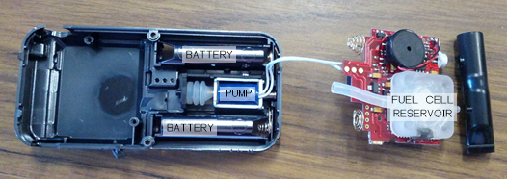

Figure - Layout of typical fuel cell breathalyser

Fuel cell breathalysers detect alcohol by measuring the current generated from the catalytic conversion of ethanol in a fuel cell. The catalyst involved in this reaction is platinum black, commonly used in Direct Alcohol Fuel Cells (DAFCs) in the development of alternative fuels, but on a much smaller scale within the breathalyser. The current produced is used to calculate the number of electrons that have been produced from the ethanol reacted, which is then used to calculate the concentration of alcohol in the sample. The measured breath alcohol concentration is translated to blood alcohol concentration by a proprietary model as established by the manufacturer. Current issues with this method are the influence temperature has on the reaction, and the limit to the rate of reaction imposed by the quantity of catalyst available.

Presently, development is focused on fuel cell technology in breathalysers, since such units can be smaller and require less energy than their infrared counterparts. As such, the primary focus is to maintain accuracy over various temperatures and alcohol concentrations.

This project aims to improve or maintain the accuracy of a fuel cell sensor breathalyser under a variety of conditions while decreasing the amount of platinum used in producing the fuel cell catalyst. This will be accomplished by producing many catalysts having a variety of platinum concentrations, then using these in polymer electrolyte membrane fuel cells attached to breath alcohol (also known as wet bath) simulators to measure their accuracy under a variety of air flow rates, temperatures, and atmospheric humidities. The warm-up time and cool-down times between each test will also be measured and optimized. Finally, the overall expected lifetime of the produced sensors will be tested.

# Literature Review

## Fuel Cell Basics

The fuel cells that will be used as sensors in this project are known as PEMFCs (Polymer Electrolyte Membrane Fuel Cells,) which convert elemental hydrogen to water to create electrical energy.

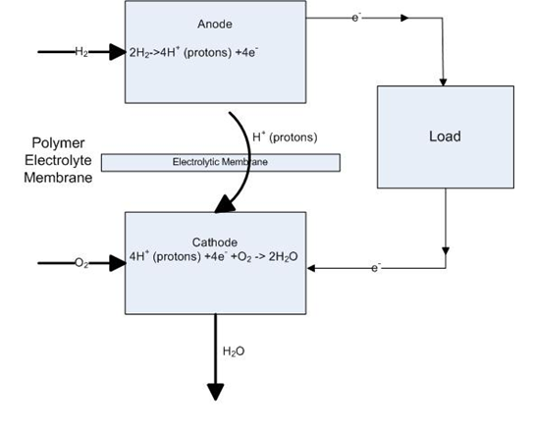

Figure - Chemical reaction within PEMFCs

The above figure shows the basic operation of a polymer electrolyte membrane fuel cell. First, hydrogen gas enters the anode, where it is split into two components: protons and electrons. The protons move across the electrolytic membrane, while the electrons pass through the load to provide energy and work, and both meet again at the cathode to recombine into hydrogen. Oxygen gas is input into the cathode, where it reacts with recombined hydrogen, to form water, the by-product of the entire process. The assembly composed of the anode and cathode with the electrolytic membrane in the centre is also referred to as the MEA, or membrane electrode assembly. (Mehta & Cooper, 2003)

While this view is highly simplified, it is the core reaction of a fuel cell; other components serve to better facilitate and increase said reaction. This project focuses on the manufacture of membrane electrode assemblies, specifically on the gas diffusion layer, a component of the electrolytic membrane.

### Membrane Composition

The electrolytic membrane to be used in this project is known as Nafion, having a composition shown below:

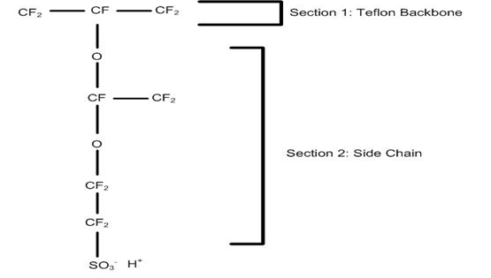

Figure - Chemical composition of Nafion (Holdcroft, 2013)

Section 1 in the figure represents the Teflon Backbone, which provides a strong structure and relative chemical stability in the membrane.

Section 2 in the figure represents the side-chain, which connects the sulphite group to the backbone, and also provides channels for osmotic flow when water is added to transfer protons. (Mauritz & Moore, 2004)

For more detailed analysis of the fuel cell, it will be necessary to perform more research on the nature and performance of Nafion, particularly in its use in PEM fuel cells under varying conditions. It may also be of interest to study the applicability of other possible membrane materials.

### Gas Diffusion Layer (GDL)

The gas diffusion layer, or GDL, is primarily made to distribute gas evenly over the catalyst and membrane layers of the fuel cell, in order to ensure optimal reaction rates. Other roles of the GDL include structural integrity, and water management. (Pasaogullari & Wang, 2004) Water management is an important part of a fuel cell, as water acts as a lubricant in allowing the formed protons to move through the electrolytic membrane. At low water concentrations, issues such as a decrease in ionic conductivity and membrane damage can occur, and at high water concentrations, issues such as flooding interfere with proper reactant feed to the fuel cell. (Benziger, Nehlsen, Blackwell, Brennan, & Itescu, 2005) The figure below is a cross-sectional view of either the cathode or anode-end of a fuel cell. A full fuel cell is completed with a similar set of the shown layers on the opposite side of the membrane. Not shown in the diagram is the catalyst layer, which is sprayed onto both sides of the gas diffusion layer.

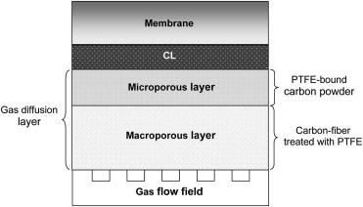

Figure – Layout of fuel cell electrolytic membrane (Park, Lee, & Popov, 2012)

### Catalyst Layer

The catalyst layer of the proton exchange membrane fuel cell plays a large role in its cost and durability. The catalyst used in fuel cell breathalysers is platinum-black, which is platinum covered in fine elemental carbon. There are three main properties of the catalyst layer to be considered in optimum fuel cell functionality. They are: porosity in the catalyst layer, ionomer distribution, and amount of catalyst available. This particular project focuses on the loading of the catalyst layer, which will directly affect all three of the above factors. (Cindrella, et al., 2009)

The primary functions of the catalyst layer are to facilitate transport to the catalyst sites and provide area for the catalytic reaction to occur. The catalyst layer is generally 5-10 μm thick, which creates mass transfer issues, which in turn reduces the efficiency of the catalytic layer (i.e. not all catalytic sites are being used due to the amount of catalyst applied.)

To apply the catalyst to the GDL, the catalyst is first mixed with an ionomer to form a dispersion solution, which is then finely sprayed in layers onto the gas diffusion layer. The added ionomer is to enhance the ability of the formed hydrogen ions to travel through the gas diffusion layer. However, this effect is limited by the size of the catalyst layer, as higher thicknesses are still mass-transfer limited despite the additional conductivity offered by the ionomer. While the optimum ionomer presently being used is perfluorosulfonic acid which is chemically similar to Nafion (Kerres, 2001), various research is being conducted into hydrocarbon ionomers, which allow for better tuning of gas permeability, water absorption, and proton conductivity, key factors in the effectiveness of an ionomer. (Holdcroft, 2013) The other solution to overcoming mass-transfer issues in the catalyst layer is to reduce its overall thickness, which is being investigated in this project.

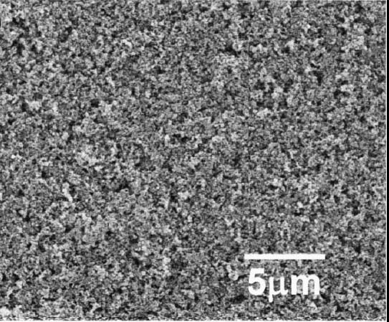

Figure – SEM image of typical catalyst layer. (Witinski)

## Thermodynamics of Water-Ethanol Solutions

The vapour liquid equilibrium between ethanol and water is of great importance in understanding the relationship between breath and blood alcohols and will be vital to the establishment of an accurate model to translate breath alcohol content to blood alcohol content. The two components behave in a non-ideal manner when in solution, thus a modified version of Dalton’s and Raoult’s law should be used to determine liquid and vapour mole fractions by taking into account activity coefficients. (Smith, Van Ness, & Abbott, 2004)

Several thermodynamic models exist to calculate the activity coefficients of water and ethanol at various temperatures, including, but not limited to: Van Laar equation, non-random two-liquid model (NRTL), universal quasichemical model (UNIQUAC), Margules activity model, Wilson’s equation, etc. (Prausnitz, Lichtenthaler, & de Azevedo, 1999)

It is possible to complete such calculations manually, however an Aspen Plus model has been created to determine the activity coefficients using the NRTL model.

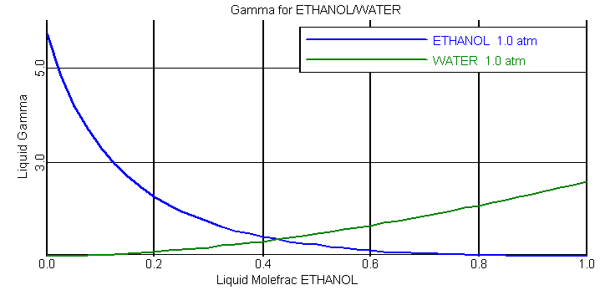

Figure - Activity coefficients of water and ethanol (NRTL) at 1 atm

As can be seen from Figure 6, the activity coefficients vary greatly over the range of ethanol mole fractions. In proceeding with the project, it will be necessary to examine more closely the pros and cons of each thermodynamics model, perform calculations or create Aspen Plus models for each under all experimental conditions, then select the appropriate one for data analysis.

## Standards and Regulations

The primary application of breath alcohol detection devices is in detecting the level of intoxication to determine whether a person is fit to operate machinery such as motor vehicles. In Canada, a blood alcohol content (BAC) of 0.08 (equivalent to 80 milligrams of alcohol per 100 millilitres of blood) is the legal limit for intoxication. Driving with a BAC above this level is a criminal offence and driving with a BAC of 0.05 can be grounds for suspension of licence in many provinces and territories. (Ministry of Transportation, 2010) Data gathered from breath alcohol detection devices is therefore an important part of the legal proceedings, so regulations exist on how accurate and how precise such instruments must be.

In cases where a police officer suspects that a driver is under the influence of drugs or alcohol, they can request breath samples which act as screening tests for immediate confirmation of intoxication level. Breath alcohol detection devices must therefore be accurate enough to detect the BAC cut-off for criminal offence of 0.05 and 0.08. The precise BAC can be determined by direct lab analysis of blood samples. Due to the sheer number of such devices available, and their widely varying accuracy and precision levels the Attorney General of Canada maintains a list of approved screening devices that meet established standards which is regularly updated to add new devices and remove old, outdated devices. (Nicholson, 2013)

In everyday use, approved screening devices are expected to be maintained and calibrated regularly, checked for expiry and back-up devices should always be available, therefore they should have a long lifetime and be easily serviced.

Although in either modifying sensors on existing devices or creating new devices there would be a lengthy process to have it approved for use in legal circumstances, there is always the personal use market, where individuals may purchase such devices to self-monitor their alcohol intake. Requirements for devices to be included on the approved list are not readily available; however the specifications of approved devices can provide a good goal to aim for in terms of accuracy, start-up time and time between tests.

# Problem Definition

## Design Problem

Breathalysers are handheld, portable devices that are used to measure a person’s blood alcohol content from a breath sample. Of the present technologies available, the most promising is that of fuel cell sensors. One of the issues facing this path is that of catalyst loading in the gas diffusion layer of the fuel cell. The catalyst used, platinum-black, is expensive even in small quantities, and the optimum application of the catalyst for this usage of fuel cell technology is still unclear. As such, the current loading of catalyst in fuel cell alcohol sensors is an area that is largely unstudied. The goal of this project is to expand that area of knowledge, and to optimize the loading of catalyst within the fuel cell gas diffusion layer.

## Overall Goal

The overall goal for the project is to decrease the loading of platinum within the catalyst coating the gas diffusion layer while producing fuel cell sensors that improve the accuracy of breathalysers. Increasing the life time of the breathalyser as well as reducing the time required for warm up and cool down between tests are secondary goals.

## Individual Objectives

1. Establish experimental setup
   1. Design experimental setup
   2. Determine design material and equipment
   3. Evaluate different options for equipment
   4. Purchase the equipment
   5. Build and set up the experiment
2. Create experimental design
   1. Design experiment to minimize number of tests
   2. Reduce original 25 design to 22 due to efficiency and time constraint
3. Prepare and produce reference solution for testing breathalyser
   1. Determine the appropriate amount of ethanol in the liquid stream that is in equilibrium with the vapour stream
   2. Create ethanol reference solution using thermodynamic calculations
   3. Verify the reference solution using experiments
4. PEM fuel cell sensor fabrication
   1. Purify Nafion membrane layer
   2. Calculate amount of platinum black added in the catalyst
   3. Prepare catalyst ink
   4. Spraying catalyst ink on the gas diffusion layer
   5. Hot pressing the membrane and the gas diffusion layer
5. Sensor testing
   1. Determine the effect of catalyst loading on response time
   2. From the sensor test, select one sensor and test at different environmental conditions and reference alcohol solutions
      1. Relative humidity, temperature and pressure
6. Data analysis
   1. Plot voltage vs time
   2. Model results in COMSOL to obtain relationship between BrAC and BAC
7. Review results
   1. Repeat any experiments as necessary
8. Recommendations

# Constraints:

The constraints for the project are the size of the product, cost and the time.

## Size

The target market for the product is a handheld device for consumers. The size of the fuel cell is then limited to the size of the portable breathalyser. The size of the gas diffusion layer is limited to 1 cm2. Design of the overall layout of the circuitry, displays, audio output and other parts of the breathalyser is outside the scope of this project and therefore is assumed to remain largely the same, which will limit the size and placement of the fuel cell.

The experimental set-up will also be limited by the amount of space available in the laboratory. The proposed equipment is fairly compact however it will still be difficult to run more than one test in parallel.

## Cost

Due to limited funding for the project, it is difficult to complete an entire prototype from scratch. The project will be using pre-existing breathalysers and doing in house modification to simulate a new prototype. Cost constraints will also increase the time required for the experiment as there is not enough equipment to run multiple experiments simultaneously.

Once all experimental objectives have been achieved, the hypothetical cost of producing a breathalyser using the tested catalysts will be calculated and the cost should be comparable to those currently available on the market.

## Time

The third and most restricting constraint is time. The experimental design requires over 10 hours to create one prototype gas diffusion layer and approximately 30 minutes to test one standard alcohol solution at one particular set of environmental conditions. In order to create a block experiment with minimal variability many consecutive hours will need to be spent in the laboratory both manufacturing and testing each individual fuel cell sensor. The total time required to repeat tests will also be constrained because the experiment requires a specific set-up and will only allow one fuel cell per test. The goal of the experiment is to complete a 22 experiment by the end of the project.

# Success criteria:

## Decreased Cost

It is desired to decrease the cost of producing a fuel cell for breathalysers. As the platinum used in producing the catalyst for the GDL contributes the largest portion of the cost, even slight reductions in the amount used will lower the overall cost of the unit a significant amount. Initial research shows that breathalyser market in 2009 is $215 million. This value is expected to increase with more and more vehicles being on the road, and the cost of the analyzers will be a big factor for the consumer market. The success criterion would be reducing the total cost by 10% as compared to the average price of comparable units currently available on the market.

## Improved Accuracy

The current average accuracy for fuel cells in breathalyser is ± 5%, for legal purposes accuracy should be higher than 95%. This will be determined using a series of sensor tests performed on both commercially available breathalysers as well as fuel cell sensors produced for this project. This will be considered successful if error in blood alcohol measurements or variance in such errors can be reduced.

## Increased Lifetime

Placing the breath alcohol analyzer in an environmental chamber can simulate accelerated aging of the breathalyser. The average lifespan of fuel cell breathalyser is 3 to 5 years; the success criterion would be to increase the average lifespan of the breathalyser to 4 to 6 years.

## Reduce Warm Up Time / Time Between Tests

In currently available models, the average time required between breathalyser tests is 20 to 30 seconds. After changing the catalyst loading on the gas diffusion layer, the time between the tests is expected to decrease by at least 5 seconds. The success criterion for the time between tests would therefore be in the range of 15 to 25 seconds. This will be measured by conducting tests of accuracy with varying times in between.

# Experimental Design

## Key Test Parameters

### Ambient Temperature

Ambient temperature will be adjusted to observe the performance of the fuel cell and other temperature-sensitive components of the breathalyser. It is expected that overall accuracy will decrease as the model translating breath alcohol to blood alcohol is less accurate at lower temperatures. Sufficiently low temperatures may also lead to mechanical failure of the pump system in the fuel cell, which could result in total shut down of the system.

### Ambient Humidity

Ambient humidity will be adjusted to observe the performance of the fuel cell under possible flooding conditions, and durability testing of the various components of the breathalyser. This also simulates real life situations of either high environmental humidity or the presence of large amounts of saliva in the user’s breath sample. In general, higher humidity is expect to produce a slight decrease in accuracy of fuel cell sensors and in accelerated degradation under wet gas testing. This can be used to test the expected lifetime of the sensor.

### Breath Flow Rate

Breath flow rate will be adjusted to observe the performance of the pump and flow sensor components of the breathalyser. Both minimum and maximum allowable flow rates will be used to ensure the sampling system (pump and motor) can adapt appropriately.

### BAC

The concentration of ethanol in the wet bath simulator is varied to simulate different blood alcohol content. This is then used to observe the accuracy of the fuel cell sensor and modelling software by comparing the BAC reading provided by the sensor to the actual concentration. In general, currently available fuel cell sensors perform accurately within a certain range, above and below which the alcohol concentration is too high to process or too low to detect, respectively.

### Acetone Concentration

Tests will be conducted with and without acetone in the wet bath simulator solution in order to measure the level of interference caused by acetone in breath. Depending on the modelling software used and breathalyser calibration, acetone may either raise the measured BAC value, or be accounted for and have no effect. If the addition of acetone does prove to negatively affect the sensor performance greatly, it will be necessary to take this into account when developing the model to translate breath alcohol content into blood alcohol content.

## Key Performance Variables

### Sensor Accuracy

The blood alcohol readings as measured by the fuel cell sensors being tested will be compared to the actual concentration of alcohol in the wet bath simulators. The individual accuracy of each sensor as well as their variances in repeated experiments will be analysed.

### Breathalyser Warm-Up Time

Fuel cells generally require some time to warm up to an ideal temperature of 30 to 40°C. This temperature best facilitates the reaction occurring within the fuel cell and it is expected that operating the sensors outside of this temperature range will affect accuracy. This can be determined by varying the warm up time before taking measurements, and verifying whether or not the accuracy is affected.

### Test Cycle Length

Experiments can be performed initially with the same period of time in between each test to obtain a baseline total time required, but once all trials have been completed the time between each test can be reduced or increased to observe if accuracy is affected.

## Selected Design Criteria

Initially, a large range of GDL catalyst loading at both the anode and cathode of sensors was desired to be tested. The full range of values to be tested can be seen in the table below. The total number of sensors to be tested was initially twenty-five, each with a different set of catalyst loading. With the lengthy testing time for each sensor, this is the most time-consuming portion of this project.

Table - Planned Catalyst Loading to be Tested

|  |  |  |  |  |  |
| --- | --- | --- | --- | --- | --- |
| Anode (mg/cm2) / Cathode (mg/cm2) | 0.2 / 0.2 | 0.3 / 0.2 | 0.4 / 0.2 | 0.5 / 0.2 | 0.6 / 0.2 |
| Anode (mg/cm2) / Cathode (mg/cm2) | 0.2 / 0.3 | 0.3 / 0.3 | 0.4 / 0.3 | 0.5 / 0.3 | 0.6 / 0.3 |
| Anode (mg/cm2) / Cathode (mg/cm2) | 0.2 / 0.4 | 0.3 / 0.4 | 0.4 / 0.4 | 0.5 / 0.4 | 0.6 / 0.4 |
| Anode (mg/cm2) / Cathode (mg/cm2) | 0.2 / 0.5 | 0.3 / 0.5 | 0.4 / 0.5 | 0.5 / 0.5 | 0.6 / 0.5 |
| Anode (mg/cm2) / Cathode (mg/cm2) | 0.2 / 0.6 | 0.3 / 0.6 | 0.4 / 0.6 | 0.5 / 0.6 | 0.6 / 0.6 |

In order to expedite the testing process, several options were considered:

Firstly, it was considered whether the sensors could be reversed, in order to switch the anode and cathode catalyst loading quantities. This would effectively reduce the number of sensors that would need to be fabricated by 50%, given the symmetry of the catalyst loading values for the anode and cathode. However, this was eventually decided to not be feasible, for two reasons: The first reason was that doing so would add additional disturbances to the data due to sensor degradation and the effects of hysteresis. The second reason was that, due to the structure of Nafion, the electrolytic membrane being used, there is a difference in behaviour when conducting hydrogen ions. As such, reversing sensor would have a high impact on performance. As such, this option was dismissed in the experimental procedure.

Secondly, batch creation of gas diffusion layers with varying catalyst loadings was considered. In order to do this, a single, large gas diffusion layer would be created, and then cut down to the required size. Since both the anode and cathode utilize the same gas diffusion layer, this would allow us to save time by producing each gas diffusion layer of a certain catalyst loading a single time, rather than the multiple times previously required. One factor that would prevent us from selecting this route is the added uncertainty when spraying catalyst for a long period of time and over a larger area. Due to the procedural nature of the spraying being performed all at once, a higher quantity of catalyst and ionomer mixture would need to be created. This would then bring up further issues such as solution settling and other composition inconsistencies, which would affect the consistency of the GDL coating, adding error to the experiments. As such, if a consistent spraying methodology and larger batches of solution can be created and maintained, this method can be used to greatly reduce GDL fabrication time, and as such reduce the overall experiment time.

Finally, by statistically refining the experimental matrix, it is possible to cut down on the number of runs that need to be run at different loading specifications, therefore reducing the total experiment time. The experimental design matrix below is the primary proposal for refining the experiment. It is a reduction of the previous 25-run design to a 22 experimental design, with an additional run at the zero-point for higher accuracy during the regression. This choice in experiment design allows for testing acceleration in two manners: firstly, due to a reduction in the number of runs before analysis is performed, re-evaluation of experimental direction can be made more frequently compared to the original experimental design. Secondly, since the points selected allow for rapid and easy analysis via linear regression, the experimental direction can be further refined, making the approach towards an optimum catalyst loading faster than a regular experiment.

Table - Planned Catalyst Loading to be Tested, Selected Parameters

|  |  |  |  |  |  |
| --- | --- | --- | --- | --- | --- |
| Anode (mg/cm2) / Cathode (mg/cm2) | 0.2 / 0.2 | 0.3 / 0.2 | 0.4 / 0.2 | 0.5 / 0.2 | 0.6 / 0.2 |
| Anode (mg/cm2) / Cathode (mg/cm2) | 0.2 / 0.3 | 0.3 / 0.3 | 0.4 / 0.3 | 0.5 / 0.3 | 0.6 / 0.3 |
| Anode (mg/cm2) / Cathode (mg/cm2) | 0.2 / 0.4 | 0.3 / 0.4 | 0.4 / 0.4 | 0.5 / 0.4 | 0.6 / 0.4 |
| Anode (mg/cm2) / Cathode (mg/cm2) | 0.2 / 0.5 | 0.3 / 0.5 | 0.4 / 0.5 | 0.5 / 0.5 | 0.6 / 0.5 |
| Anode (mg/cm2) / Cathode (mg/cm2) | 0.2 / 0.6 | 0.3 / 0.6 | 0.4 / 0.6 | 0.5 / 0.6 | 0.6 / 0.6 |

By combining the second and the third options, it is possible to reduce GDL fabrication down to three runs of 0.2, 0.4, and 0.6 mg/cm2 loading. From these initial runs, it will then be possible to perform a statistical regression in order to determine the next set of catalyst loading to be tested.

In terms of runs to determine accuracy and repeatability of the sensors, a matrix similar to the one below will be used. Since this part of the experimental procedure is not highly time-consuming, a higher variety of points can be tested.

Table - Planned Environmental Effect to be Tested

|  |  |  |  |  |
| --- | --- | --- | --- | --- |
| Temp (°C) / Relative humidity (%) | -10 / 10% | 0 / 10% | 10 / 10% | 20 / 10% |
| Temp (°C) / Relative humidity (%) | -10 / 30% | 0 / 30% | 10 / 30% | 20 / 30% |
| Temp (°C) / Relative humidity (%) | -10 / 50% | 0 / 50% | 10 / 50% | 20 / 50% |
| Temp (°C) / Relative humidity (%) | -10 / 70% | 0 / 70% | 10 / 70% | 20 / 70% |
| Temp (°C) / Relative humidity (%) | -10 / 90% | 0 / 90% | 10 / 90% | 20 / 90% |

# Experimental Set-Up & Procedure

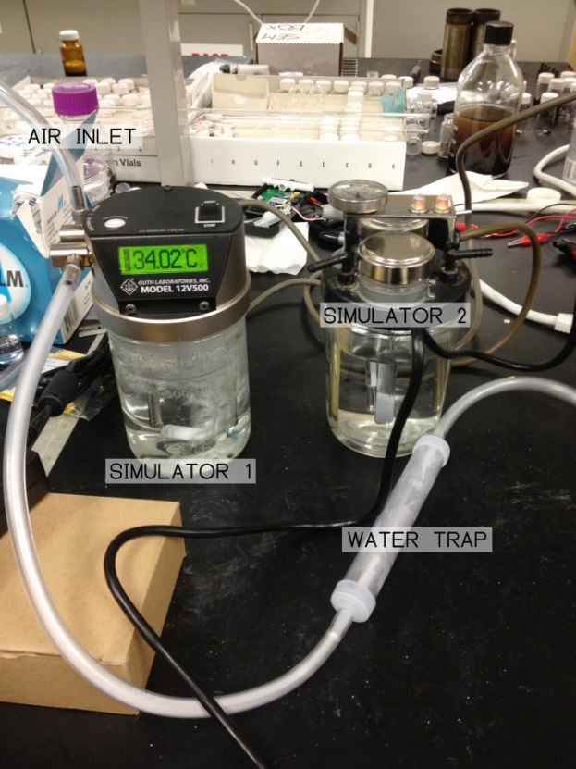

Figure - Experimental set-up with two wet bath simulators

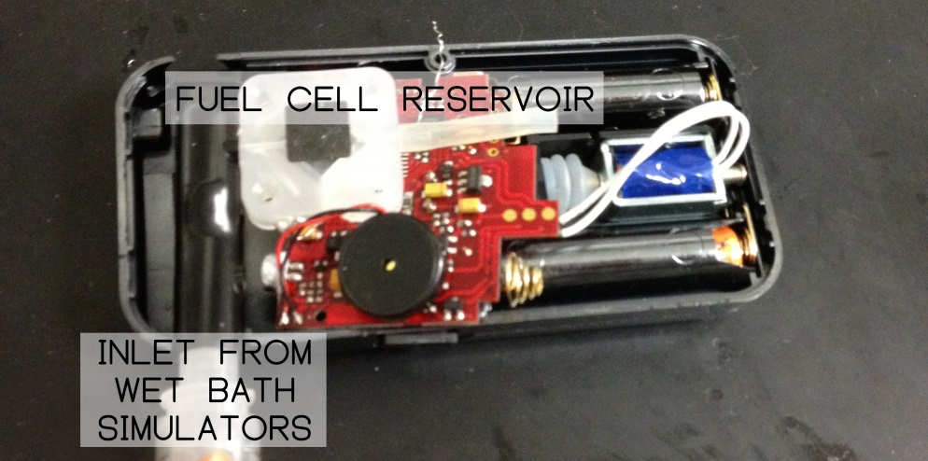

Figure - Fuel cell in breathalyser assembly

## Simulation Solution Creation

Although a few standardized solutions that will produce the desired breath and blood alcohol measurements have been purchased, a large number of experiments are planned for varying environmental conditions, therefore once thermodynamic analysis of water-ethanol vapour liquid equilibrium is complete, pure ethanol and deionized water will be used to prepare such solutions.

## Experimental Procedure

### Sensor Fabrication

Sensor fabrication is subdivided into the following 4 steps:

1. Pre-processing of Nafion (Required due to age of membrane leading to possible degradation)
   1. Cut appropriately sized section of Nafion membrane
   2. Boil membrane in 3% aqueous solution of H2O2 for 1 hour until the membrane changes colour from yellow to clear
   3. Rinse with deionized water 3 times and boil in deionized water for 1 hour
   4. Boil membrane in 1mol/L H2SO4 for 1 hour
   5. Rinse with deionized water 3 times and boil in deionized water for 1 hour
2. Preparation of catalyst ink
   1. Determine the desired loading of catalyst, calculate to determine mass of catalyst required
   2. Weigh the required platinum black catalyst
   3. Wet powdered catalyst with a drop of deionized water
   4. Add 2-propanol to the flask containing the catalyst, followed by the treated Nafion membrane
   5. Seal the flask top with Parafilm
   6. Sonicate for 2 to 4 hours
3. Coating
   1. Measure and record mass of dry GDL
   2. Disassemble air brush, wash each part in ethanol
   3. Sonicate parts in ethanol for 1 hour
   4. Load small amounts of prepared catalyst ink into air brush at a time
   5. Adjust air flow rate and air brush opening
   6. Tape dry GDL to warmed heat plate
   7. Spray catalyst onto GDL using air brush with slow, even strokes, reloading with more ink as necessary
   8. Once all the ink is used, disassemble gun and clean immediately using ethanol
   9. Measure and record mass of sprayed GDL
4. Hot pressing
   1. When 2 GDLs having the desired loading have been prepared, select one to use as anode and another as cathode
   2. Set hot press to 135°C
   3. Add 2 to 3 drops of Nafion solution to the surface of cathode and anode, allow to dry at ambient temperature and pressure
   4. Place treated Nafion membrane between cathode and anode
   5. Hot press at 10MPa for 3 minutes

### Sensor Testing

After the sensor has been fabricated and mounted to a pump system that is suitable for the sensor sample reservoir, the following steps are taken:

1. Prepare and start the water/zero simulator
2. Prepare a solution using deionized water and ethanol to create the desired BAC
3. Load the prepared solution into the other simulator and start the simulator
4. Place the sensor and pump system into the environmental chamber, if abnormal ambient conditions are required for testing
5. Wait 30 minutes for the simulators and environmental chamber to reach equilibrium
6. Samples from the BAC and zero simulators will be alternatively injected into the mouthpiece of the pump system at 20-30 second intervals depending on the sensor reset time until the desired amount of runs are achieved as follows:
   1. Start a breathalyser testing cycle
   2. Connect the air supply to one of the simulators
   3. Connect the simulator outlet to the breathalyser input
   4. Wait until the sample has been taken by the pump
   5. Disconnect the air supply from the simulator
   6. Disconnect the simulator from the breathalyser input
   7. Record required values
7. Afterwards, depending on the required test, additional ethanol may be added to the simulators to record performance under varying BACs, or clean-up of equipment will be required to conclude the experiment

# Preliminary Experiment Results and Observations

Currently one membrane electrode assembly (for lab procedure training and initial testing purposes) has been fabricated having a theoretical loading: 0.5mg/cm2. (For detailed calculations see Appendix A – Sample Calculations).

The spraying of the catalyst ink onto the GDL was found to be somewhat uneven, resulting in visible streaks of varying colours across the surface of the GDL. It was thus determined that this sample would be inappropriate for use in further testing and that the air pressure and nozzle opening of the air brush should be adjusted for the next round of fabrications.

It was also suggested that due to the time required to evenly coat the GDL as well as the large impact that streaky application would have on GDL performance, automating the process would greatly expedite and standardize the process. The use of a robotic arm constructed out of easily available LEGO® MINDSTORMS® pieces could be an economical and easily constructed solution. Time and budget constraints may limit the availability of this equipment, although it is currently under consideration. A more detailed plan will be created if necessary.

# Risk Analysis

## Identified Risks

### Insufficient Funding

Funding for the project is limited and equipment for the experiment can be very costly. When evaluating equipment for the different experimental set-ups available, performance and the cost of purchasing were evaluated and optimized to select a reasonably priced configuration. Due to the cost constraint a limited amount of equipment was purchased. In case of equipment failure, particularly in the wet bath simulators or airbrush, there would be no back-up equipment to continue testing, putting further limits on the amount of time available for experimentation. Another risk identified with a limited budget is the equipment life time. One of the wet bath simulators was purchased second-hand and contains a heating unit and impeller which have been prone to malfunctioning, thus there is a higher risk of failure for that unit in particular. This is a serious risk and may potentially compromise the experiment.

### Unable to Complete All Experiments

A serious risk that has been noted is the constraint on time leading to unfinished experiments. This hinders the progress, particularly in the data analysis portion, as the experimental design requires repeated results in blocks for accurate analysis.

## Mitigation Strategies

For the experiment, two breath simulators are required to test the accuracy of the GDL in the breathalyser. One of the breath simulators is filled with an alcohol solution that was been calibrated at a certain BAC level. The other breath simulator is filled with water, to zero the breathalyser. In a case where one simulator has failed, the experiment can still proceed by using the functional simulator for the alcohol solution and using the failed simulator for the zero, water simulator. The basic function of the zero is to run water through the simulator so the exiting air stream contains moisture like in the human breath. The functional breath simulator includes a temperature controller to maintain the liquid at 34°C similar to human body. It also has a working impeller that mixes the solution to ensure the alcohol is evenly distributed in the liquid. For the zero water simulator, it would still be usable if the impeller and the temperature controller did not work because there is no need to mix the solution of pure water.

The experiments will be done in blocks with the minimum amount of catalyst loading, maximum amount of catalyst loading and the average amount first. This will ensure that even if there is no time for further experimentation, there will still be three points of data on which to interpolate for data analysis.

# Health, Safety and Environment

## Health and Safety

Breathalysers have been in use since 1927; since they have always been a commercial product, improvements have continuously been made to ensure its safety and ease of use.

The use of breathalysers in general is beneficial to the health and safety of the general public: “in 2002, 17,419 (41%) of 42,815 traffic deaths were alcohol related”. (Quinlan, et al., 2005) . The availability and use of cheap commercial breathalysers will help to greatly reduce such incidents. Currently breathalysers cost approximately $200-300 each and are either not portable or not accurate enough for consumer use. The new PEMFC design will allow breathalysers to be made smaller, reducing the cost of materials and production. This decrease in cost could serve as a great incentive for people to monitor their BAC more closely, so as to avoid drinking and driving.

Another important use of breathalysers is in the integration with an interlock feature. This would be installed in the user’s vehicles and automatically lock the car once the BAC tested is above legal limits, effectively preventing the ability to drink and drive entirely.

The platinum black powder used in production of the fuel cell can be hazardous as the fine platinum particles are quite flammable so it is kept always from sparks and only used in fume hoods. Proper personal protection equipment such as masks, gloves, lab coats and closed-toed shoes are also required while working with the catalyst due to how fine the powder is as it can easily become airborne and cause skin irritation as well as internal damage due to accidental inhalation. These issues may become more prevalent if production of fuel cells is scaled up to a commercial level.

## Environment

The current breathalyser shell is made of injection modeled plastic which is not recyclable. This means the plastic remains in the environment once the breathalyser’s effective lifetime has elapsed and will take up to 1000 years to biodegrade. When plastic components do eventually break down, methane is released, which contributes to global warming. Plastic also poses an environmental hazard to small animals who can choke on the hard, indigestible pieces. By making breathalysers more compact, the total amount of plastic used can be reduced, lowering the environmental impact both in terms of energy and material use during manufacturing, as well as eventual waste disposal.

The circuit boards used in breathalysers also contain various heavy metals such as tin, lead, copper, etc. Heavy metals can be carcinogenic, affect the reproductive system, and cause cardiovascular diseases. Such heavy metals must be properly disposed of separately from other components, however in general consumers will not disassemble the breathalyser at the end of its useful lifetime and dispose of each component separately, so it is possible that the heavy meatls will be leached into the soil or water of a landfill and have a very negative impact on the environment. Although there are no plans in the scope of this project to reduce the amount of heavy metals used in the circuitry, the reduction of platinum used in the catalyst will serve to reduce heavy metal pollution very slightly.

The last main component of the breathalyser is the batteries used. Batteries have long been known for causing environmental harm from improper disposal due to its chemical contents. Typically AA alkaline batteries are used; such batteries contain chemicals including zinc, manganese dioxide and potassium hydroxide. While in small quantities they do not pose a great danger to human health and safety, when allowed to decompose in a landfill, they can quickly enter the ecosystem and affect wildlife through bioaccumulation. The use of rechargeable batteries can greatly reduce the negative environmental impact. With lifecycle analysis, appropriate battery use to minimize environmental damage can also be recommended. Finally, the use of fuel cells as an alternative fuel can reduce heavy metal pollution as well as greenhouse gas emissions; experimental data gathered on GDL performance can provide insight into fuel cell operation and an empirical basis for further fuel cell refinements.

## Economics

This project is attempting to reduce the amount of platinum used by 0.2mg/cm2 for both the anode and cathode side of the breathalyser fuel cell. This will reduce the overall cost of the breathalysers because the main cost of fuel cells resides in the platinum catalyst. Price for the platinum black catalyst is around $500 USD/gram, and each completed cell measures approximately 1cm2 which means 20 cents will be saved per fuel cell.

Sales of personal breathalysers has increased dramatically in the last few years and are predicted to increase even more over the next few year. The following graph indicates sales of breathalysers in the recent years as well as projected sales.

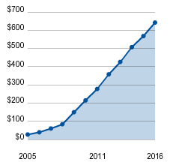

Figure - Sales of personal breathalysers in millions (Sales from 2011 onward projected values)

(Lackey, 2009)

According to USA Today (Lackey, 2009), sales of personal breathalysers were approximately $15.2 million USD in 2009. The average price of each breathalyser is approximately $200 USD, this indicated that 1,076,000 units were sold in 2009 alone. Assuming that 30% of the units sold were fuel cell breathalysers, and multiplying that by amount saved per unit, it should amount to $64,560 saved per year on fuel cells alone.

If possible, this project will also investigate reducing the amount of plastic used for the enclosure and various other components of the breathalyser, which could lead to savings in both raw material and production costs.

Once more experiments have been performed and data is available, a more detailed economic analysis including the cost breakdown of individual fuel cell and breathalyser components can be performed to determine where other cost savings may be made.

# Appendix A – Sample Calculations

$$m_{\frac{Pt}{C}}=\frac{A×Q_{Pt}}{η×w_{Pt}} \\ m_{\frac{Pt}{c}}=\frac{\left(1.1cm×1.1cm×2×4\right)\left(\frac{0.5mg}{cm^{2}}\right)}{\left(0.7\right)\left(0.253\right)} \\ m_{\frac{Pt}{c}}=13.39mg$$

$m_{\frac{Pt}{c}}=mass of platinum black catalyst required$

$$A=effective area of MEA including both sides of cathode and anode$$

$$Q_{pt}=theoretical loading of platinum$$

$$η=recovery ratio of coating$$

$$w_{pt}=platinum content in platinum black catalyst (25.3\% for catalyst powder used)$$

$$m_{Nafion}=\frac{m_{\frac{Pt}{C}}}{w_{Nafion}}∙\frac{k_{nafion}}{k_{\frac{Pt}{C}}} \\ m_{Nafion}=\frac{\left(13.39mg\right)}{0.04}∙\frac{1}{2} \\ m_{Nafion}=167.39mg$$

$m_{Nafion}=mass of Nafion required$

$$k_{Nafion}=ratio of Nafion in the slurry \left(1\right)$$

$k_{\frac{Pt}{c}}=ratio of platinum black catalyst in the slurry (2)$

$w_{Nafion}=concentration of Nafion solution (4\% for solution used)$

$$V_{Nafion}=\frac{m_{Nafion}}{ρ_{Nafion}}=\frac{167.39mg×\frac{1g}{1000mg}}{\frac{0.6g}{cm^{3}}} \\ V_{Nafion}=0.28mL$$

$V_{Nafion}=volume of Nafion solution required$

$ρ_{Nafion}=density of Nafion solution (approx. 0.6\frac{g}{cm^{3}} used)$

# Appendix B - Bibliography

Benziger, J., Nehlsen, J., Blackwell, D., Brennan, T., & Itescu, J. (2005). Water ﬂow in the gas diffusion layer of PEM fuel cells. *Journal of Membrane Science*, 98-106.

Cindrella, L., Kannan, A., Lin, J., Saminathan, K., Ho, Y., Lin, C., & Wertz, J. (2009). Gas diffusion layer for proton exchange membrane fuel cells—A review. *Journal of Power Sources*, 146-160.

Holdcroft, S. (2013). Fuel Cell Catalyst Layers: A Polymer Science Perspective. *Chemistry of Materials*, A-M.

Kerres, J. A. (2001). Development of ionomer membrane for fuel cells. *Journal of Membrane Science*, 3-27.

Lackey, K. (2009, December 22). *Sales of Personal Breathalyzers Spike*. Retrieved from USA Today: http://usatoday30.usatoday.com/news/nation/2009-12-22-personal-breathalyzers-sales-increase_N.htm

Mauritz, K. A., & Moore, R. B. (2004). State of understanding of Nafion. *Chemical Reviews*, 4535-4585.

Mehta, V., & Cooper, J. S. (2003). Review and analysis of PEM fuel cell design and manufacturing. *Journal of Power Sources*, 32-53.

Ministry of Transportation. (2010, December 29). *Impaired Driving.* Retrieved from Ontario Ministry of Transportation: http://www.mto.gov.on.ca/english/safety/impaired/

Nicholson, R. D. (2013, June 19). *Order Amending the Approved Breath Analysis Instruments Order.* Retrieved from Canada Gazette: http://www.gazette.gc.ca/rp-pr/p2/2013/2013-06-19/html/sor-dors107-eng.php

Park, S., Lee, J.-W., & Popov, B. N. (2012). A review of gas diffusion layer in PEM fuel cells. *International Journal of Hydrogen Energy*, 5850–5865.

Pasaogullari, U., & Wang, C. Y. (2004). Liquid water transport in gas diffusion layer of polymer electrolyte fuel cells. *Journal of The Electrochemical Society*, A399-A406.

Prausnitz, J. M., Lichtenthaler, R. N., & de Azevedo, E. G. (1999). *Molecular Thermodynamics of Fluid-Phase Equilibria 3rd Ed.* Englewood Cliffs: Prentice-Hall.

Quinlan, K. P., Brewer, R. D., Siegel, P., Sleet, D. A., Mokdad, A. H., Shults, R. A., & Flowers, N. (2005). Alcohol-impaired driving among U.S. adults, 1993-2002. *American Journal of Preventive Medicine*, 346-350.

Smith, J., Van Ness, H., & Abbott, M. (2004). *Introduction to Chemical Engineering Thermodynamics.* Boston: McGraw-Hill.

Witinski, P. (n.d.). *Catalyst Layer of a PEM Fuel Cell Membrane*. Retrieved from University of Rochester Institute of Optics: http://www.optics.rochester.edu/workgroups/cml/opt307/spr05/paul/